GSE Geometry Circles Review Part A Name _________________

In 1-2, use to find the value of *x*. Then, find the arc measures.

1. 2.

 

 

Find the measure of the indicated arc or angle in .

3. _?_ 4. _?_ 5. _?_

Find the value of each variable.



6. 7. 8.

9. 10. 11.

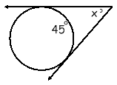

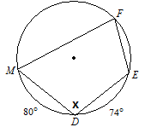

12. Find the **area** and **arc length** of the shaded region.

13. The area of one piece of pizza is . The pizza is cut into eighths. Find the radius of the pizza pie.

14. Determine the radius of the circle with a circumference of . Use the radius to

then find the area.

15. A sprinkler system can shoot water at a distance of 15 yards. It is set up to rotate

240 degrees. How much area of the yard is covered by the sprinkler?

1. The clock in our classroom has a radius of 9 inches. If it’s 4:00, find the arc length and area of the sector for this time.