### Name: __________________________________________ Date: _____________________________

**Central Angles Homework**

**1. Identify and name each of the following from 🖸O. Be sure to use the correct notation.**

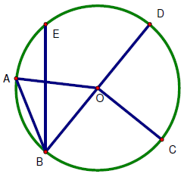

1. Two different central angles
2. A minor arc
3. A major arc
4. A semicircle
5. Two different chords
6. The central angle subtended by 

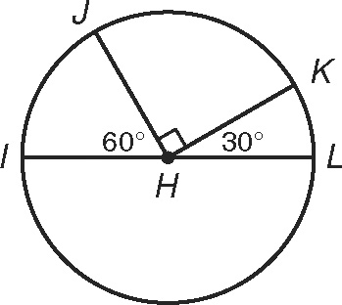**Find each measure.**

2.  ________,_______

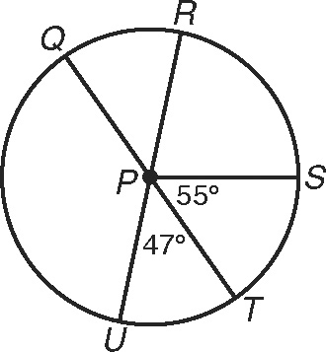

3. 

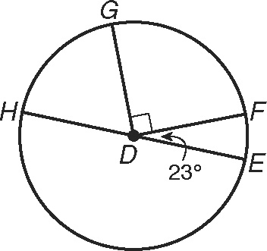

4. 

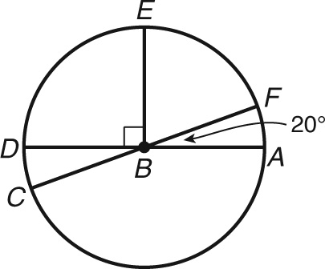

5. 

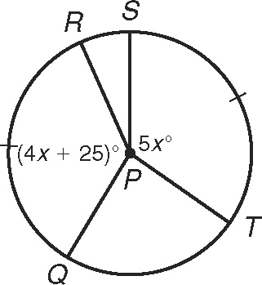

6.  ___________

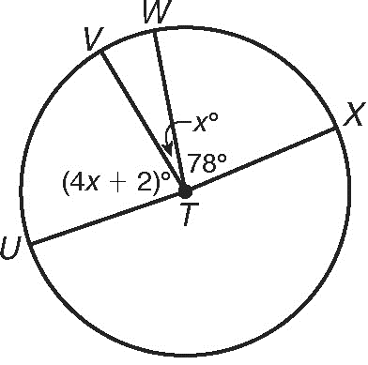

7.  _______,________