### Name: __________________________________________ Date: _____________________________

**Central Angles Classwork – Practice**

**Name the arc shown in bold and classify it (minor, major, or semi).**

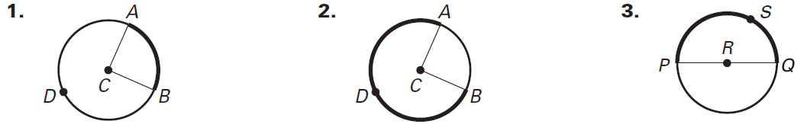

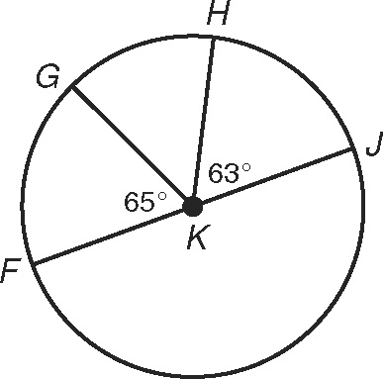**Find each measure.**

**4.**  ____________

**5.**  ____________

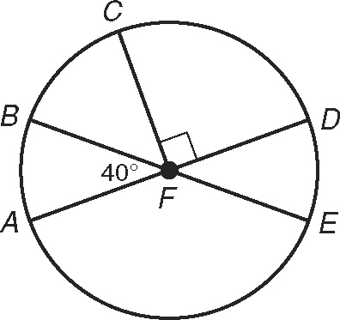

**6.**  ____________

**7.**  ____________

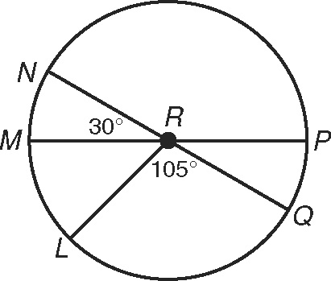

**8.**  ____________

**9.**  ____________

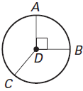

**10.** ____________

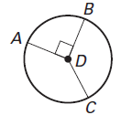

**11.** ____________

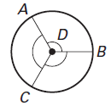

**12.**  ____________