### Name: __________________________________________________________________ Date: _____________________

**Partitioning Line Segments in 2 Dimensions Practice with Task**

**MCC9-12.G.GPE.6** Find the point on a directed line segment between two given points that partitions the segment in a given ratio.

1. Given the points A(-3, -6) and B(7, 9), find the coordinates of the point P on directed line segment  that partitions  in the ratio 2:3.
2. Given the points A(3, -4) and B(9, 5), find the coordinates of the point P on directed line segment  that partitions  in the ratio 2:1.
3. Given the points A(-3, 0) and B(9, 8), find the coordinates of the point P on directed line segment  that partitions  in the ratio 3:1.

**Use the map and the information given to solve each problem that follows.**

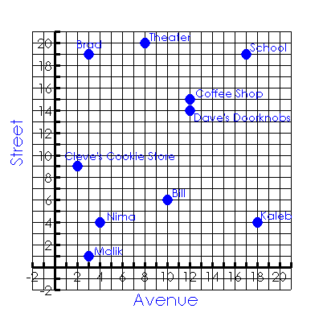

1. Luis works at a theater on 8th Avenue and 20th Street. Kaleb lives at the corner of 18th Avenue and 4th Street. What is a possible location that is midway between them?
2. Nima lives at the corner of 4th Avenue and 4th Street. Bill lives at the corner of 10th Avenue and 6th Street. Their favorite bakery is located midway between them. What is one possible location of the bakery?
3. Cleve’s Cookie Store is located at the corner of 2nd Avenue and 9th Street. Dave’s Doorknobs is located at the corner of 12th Avenue and 14th Street. Located of the distance from Cleve’s Cookie Store is the post office. Where is the post office?
4. Malik and Brad both live on 3rd Avenue. Malik lives at the corner of 1st Street, and Brad lives at the corner of 19th Street.  of the distance from Malik’s apartment to Brad’s apartment is a market. Where is the market?
5. The main entrance to the high school is located at the corner of 17th Avenue and 19th Street. On his way from school to the bank, Luis stops at the coffee shop located at 12th Avenue and 15th Street. The coffee shop is the midpoint of this trip. What is the location of the bank?