Lesson 6.2 Practice: Explain how you know that the triangles are similar. (AA, SSS, SAS)
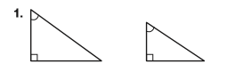 |  | 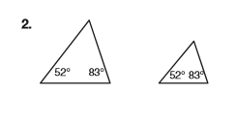
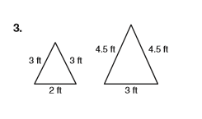 |  | 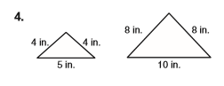
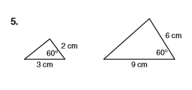 |  | 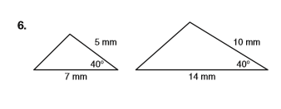
Determine what additional information you would need to prove that the triangles are similar using the given theorem.
7. What information would you need to use the Angle-Angle Similarity Theorem to prove that the triangles are similar? | 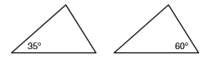
8. What information would you need to use the Angle-Angle Similarity Theorem to prove that the triangles are similar? | 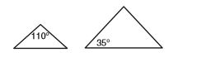
9. What information would you need to use the Side-Angle-Side Similarity Theorem to prove that the triangles are similar? | 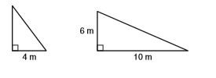
10. What information would you need to use the Side-Angle-Side Similarity Theorem to prove that the triangles are similar? | 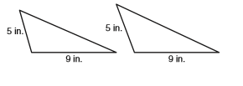
11. What information would you need to use the Side-Side-Side Similarity Theorem to prove that these triangles are similar? | 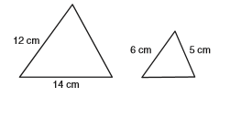
12. What information would you need to use the Side-Side-Side Similarity Theorem to prove that these triangles are similar? | 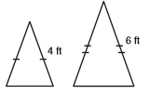
Determine whether each pair of triangles is similar. Explain your reasoning.
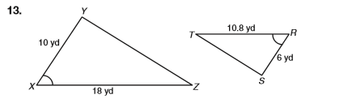 | 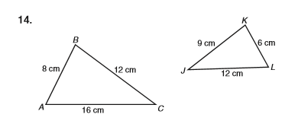
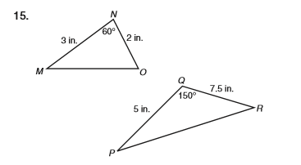 | 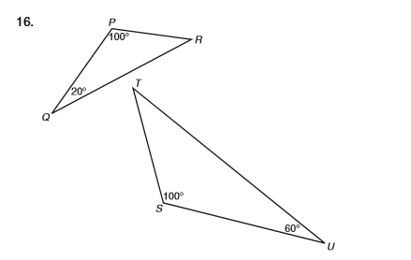
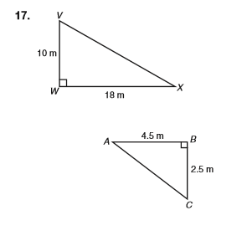 | 