**1. Mutually exclusive events**. Suppose that you select a person at random from your school. Are these pairs of events mutually exclusive?

a) has ridden a roller coaster; has ridden a Ferris wheel

b) owns a classical music CD; owns a jazz music CD

c) is a senior; is a junior

d) has brown hair; has brown eyes

e) is left-handed; is right-handed

f) has shoulder-length hair; is male

**2. More Dice.** Use the general addition rule to compute the probability that if you roll two six-sided dice,

a) you get doubles or a sum of 4

b) you get doubles or a sum of 7

c) you get a 5 on the first die or you get a 5 on the second die.

**3. Mr. Leary’s Class.** Use the Venn Diagram showing the number of kids owning bicycles (A) and skateboards (B) to find the following probabilities.



a) . What does this probability represent?

b) . What does this probability represent?

c) . What does this probability represent?

**4. Pizza.** Of the 220 people who came into the Italian deli on Friday, 104 bought pizza and 82 used a credit card. Half of the people who bought pizza used a credit card. What is the probability that a customer bought pizza or used a credit card?

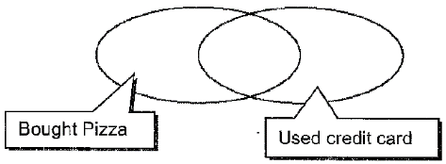

**5. Sports Teams.** A group of 60 students were asked if they played field hockey (F), basketball (B) or soccer (S). The diagram below displays the results. Use the information given to find the following probabilities.

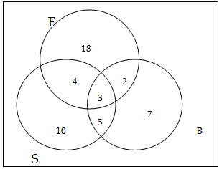

a) 

b) 

c) 

c) 

d) 

**6.** Given the Venn Diagram below with set A and set B determine the following:





B

A





a)  b) 

c)  d) 

**7. Swim and whistle**. Suppose 80% of people can swim. Suppose 70% of people can whistle. Suppose 55% of people can do both. What percentage of people can swim or whistle?

**8. Backpack and wallets**. At Cartersville, 60% of the students carry a backpack or a wallet. 40% carry a backpack, and 30% carry a wallet. If a student is selected at random, find the probability that the student carries both a backpack and a wallet.