~Mutually Exclusive & Overlapping Events Notes~
- Compound event:
- Mutually Exclusive:
- Overlapping:
- Mutually Exclusive formula:
- Overlapping Events formula:
- Or means:
- And means:
Example 1:  - Find the probability that a girl’s favorite department store is Macy’s or Nordstrom. | Macy’s 0.25  Saks 0.20  Nordstrom 0.20  JC Penny’s 0.10  Bloomingdale’s 0.25
- Find the probability that a girl’s favorite store is not JC Penny’s.

Example 2:  - When rolling two dice find  - P(sum 4 or sum 5) | 1 2 3 4 5 6  1 2 3 4 5 6 7  2 3 4 5 6 7 8  3 4 5 6 7 8 9  4 5 6 7 8 9 10  5 6 7 8 9 10 11  6 7 8 9 10 11 12

Example 3:  - In a deck of cards, find  P(Queen or Ace) | - 52 total cards  - 4 Suits  - 13 cards in each suit  - 3 Face cards in each suit
Example 4:  - Find the probability that a person will drink both.  - A = drink coffee  - B = drink soda | 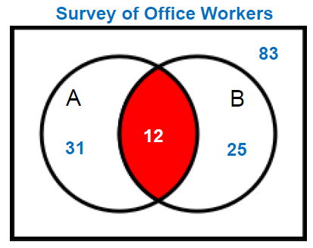

Example 5:  - Find the P(A ∪ B)  - A = band members  - B = club members | 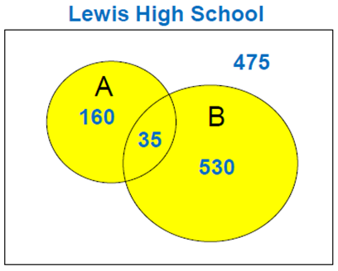

Example 6:
- In a deck of cards find
P(King or Club)

Example 7:  - Find the P(picking a female or a person from Florida). | Female Male  FL 8 4  AL 6 3  GA 7 3

Example 8:  - When rolling 2 dice, find P(an even sum or a number greater than 10). | 1 2 3 4 5 6  1 2 3 4 5 6 7  2 3 4 5 6 7 8  3 4 5 6 7 8 9  4 5 6 7 8 9 10  5 6 7 8 9 10 11  6 7 8 9 10 11 12

Example 9: Complementary Events
Find

