For each exercise, you MUST draw a picture, set up the equation, and solve.
Angle of Elevation:  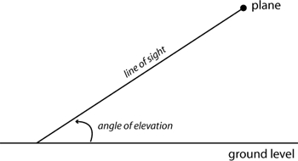 | Angle of Depression:  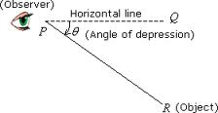
- A 60 – foot extension ladder leans against the side of a building. Find the distance up the side of the building if the angle of elevation of the ladder is 72 degrees.

- The pilot of an airplane flying at 14,000 feet sights a water tower. The angle of depression to the base of the tower is 19 degrees. What is the length of the line of sight from the plane to the tower?

- An airplane leaves the runway climbing at 19 degrees with a speed of 270 feet per second. Find the altitude of the plane after 1 minute.

- The angle of depression from the top of a building to the base of a statue 42 feet from the base of the building is 71 degrees. Determine the height of the building.

- From a point on a cliff 72 feet above water level an observer can see a ship. The angle depression to the ship is 6 degrees. How far is the ship from the base of the cliff?

- The ramp approaching a loading platform that is 5 feet off the ground is to have an angle of 17 degrees with the ground. Find the length of the ramp.

- Find the height of a tree that casts a 25 foot shadow when the angle of elevation to the sun is 52°.

- As a submarine at the surface of the ocean makes a dive, its path makes an angle of 22° with the surface of the water. If the sub travels for 315 meters along this path, how deep will it be?

