~Chord Properties~
- If ______ chords are _____________, then their corresponding ______ are congruent.

Solve for x:  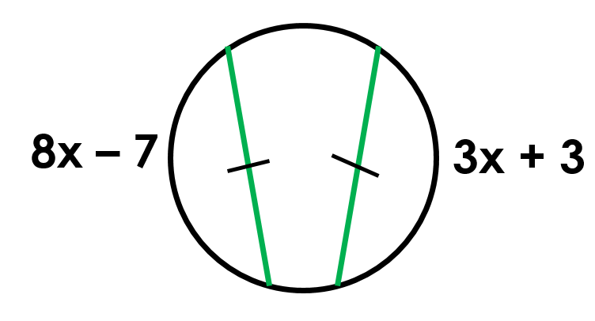 | Find WX:  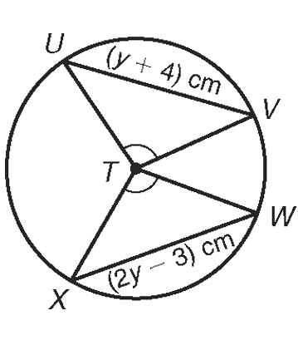
Find 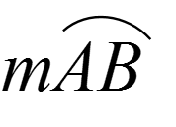

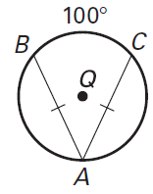

- If two ________ are congruent, then they are_______________ from the center.

In K, K is the midpoint of RE. If TY = -3x + 56 and US = 4x, find the length of TY. | 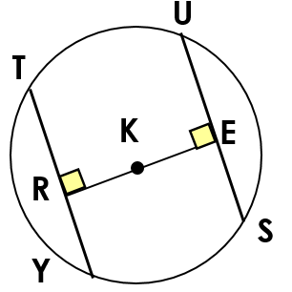

- If a _____________ is ___________________ to a chord, then it also _________ the chord. This results in _____________arcs too. Sometimes, this creates a ________ ___________ & you’ll use __________________ Theorem.
IN Q, KL ≅ LZ. If CK = 2x + 3 and CZ = 4x, find x.  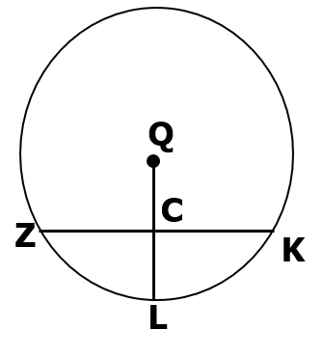 | In P, if PM ⊥ AT, PT = 10, and PM = 8, find AT.  