### Name: __________________________________________ Date: _____________________________

**Volume of Pyramids & Cones**

**Find the volume of each of the following and round to the nearest tenth.** 

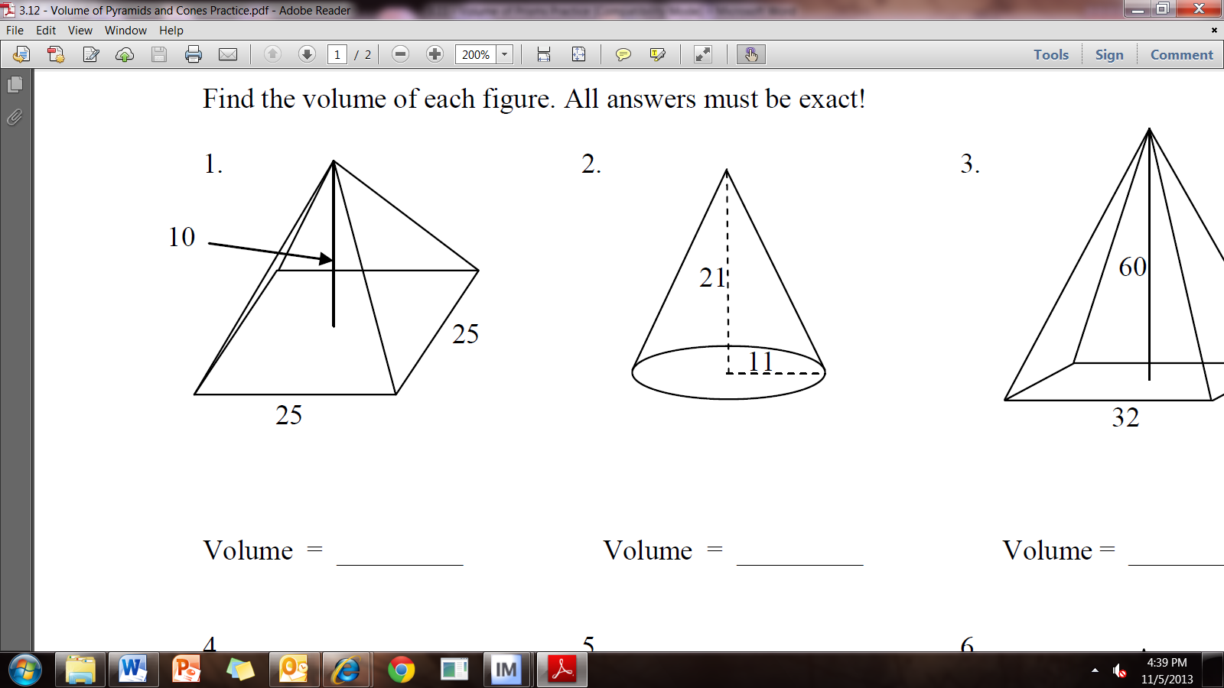

1. 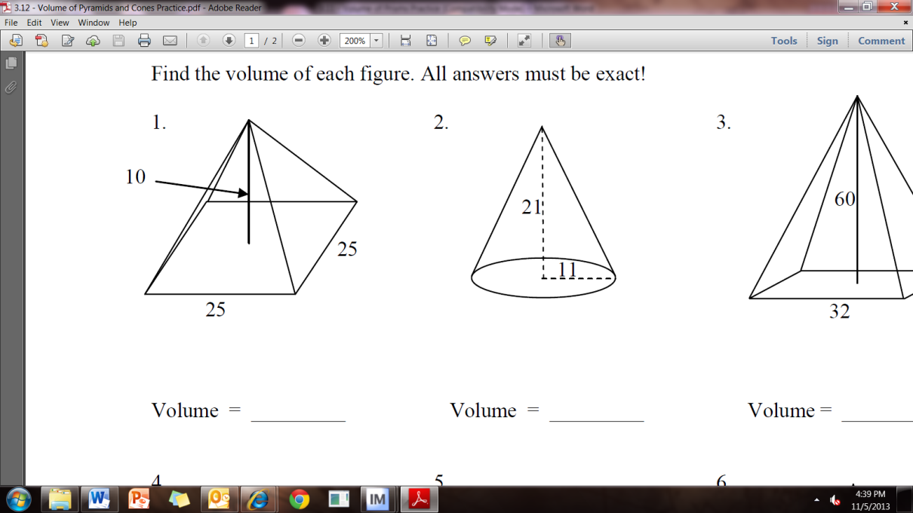
2. 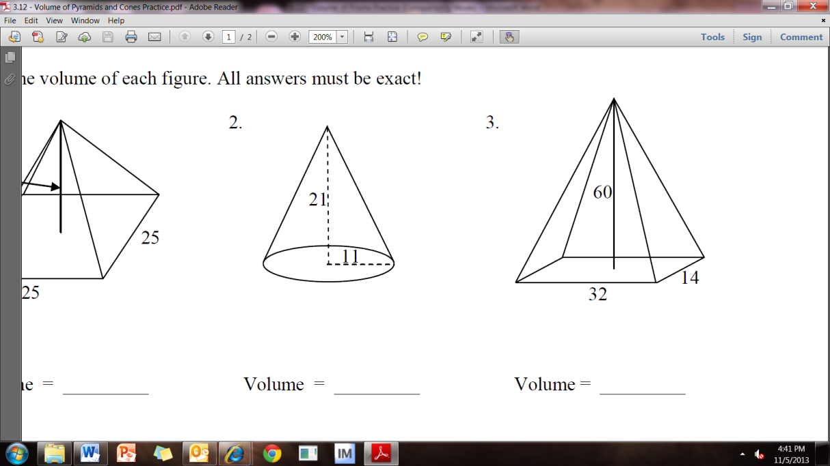

1. 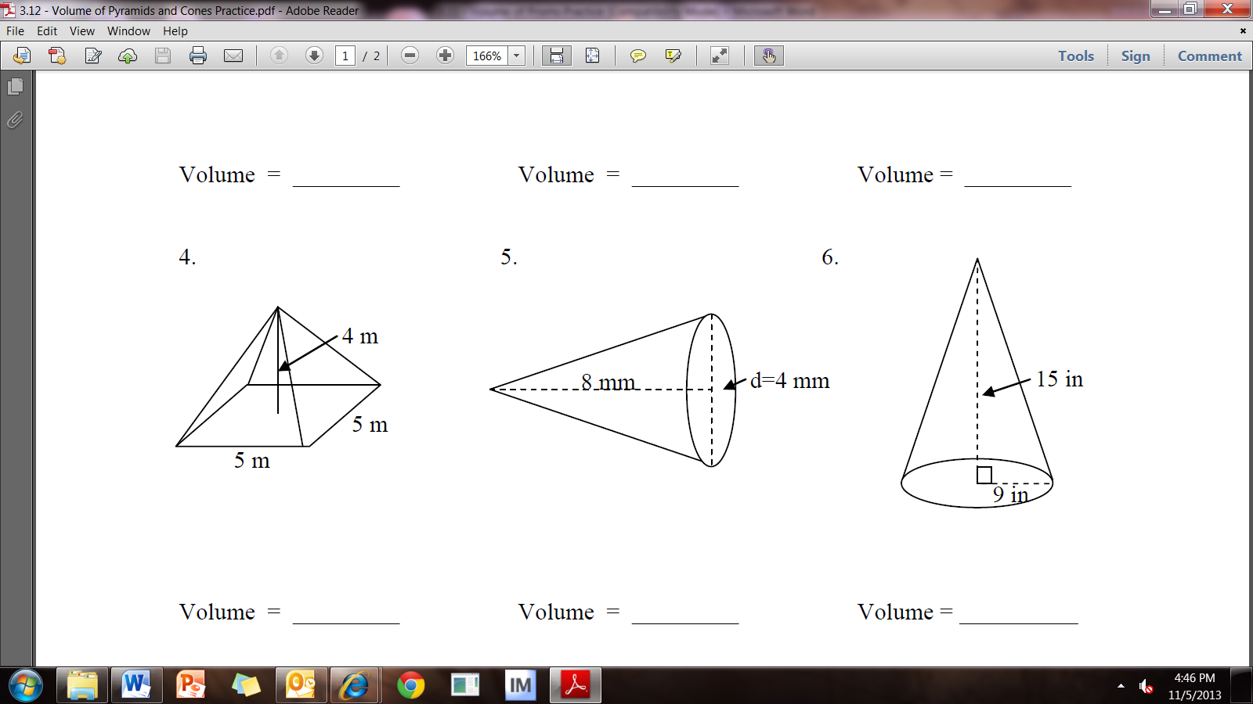
2. 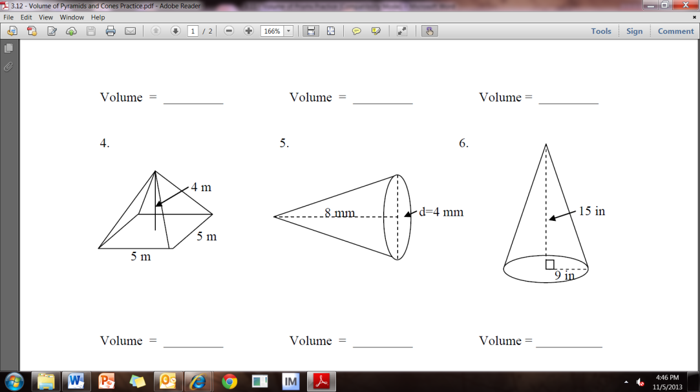
3. 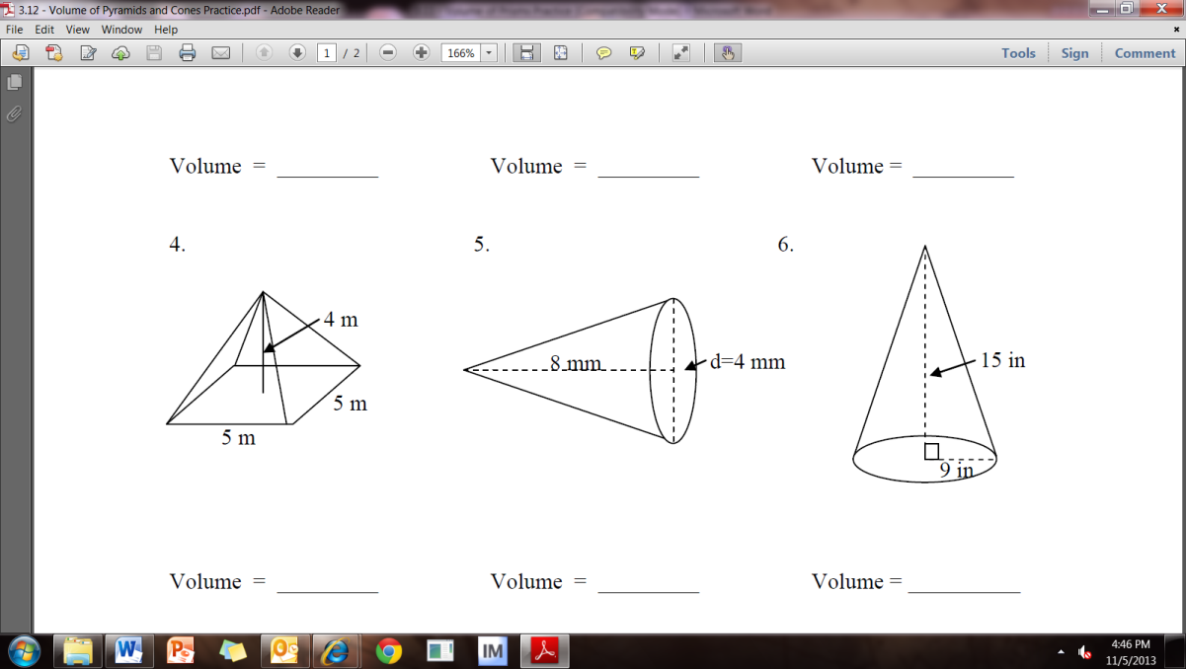
4. Square Pyramid side = 9 in Height = 12 in
5. Cone, Radius = 8 cm Height = 15 cm
6. Triangular Pyramid Base Area = 15 m2 Height = 20 m
7. 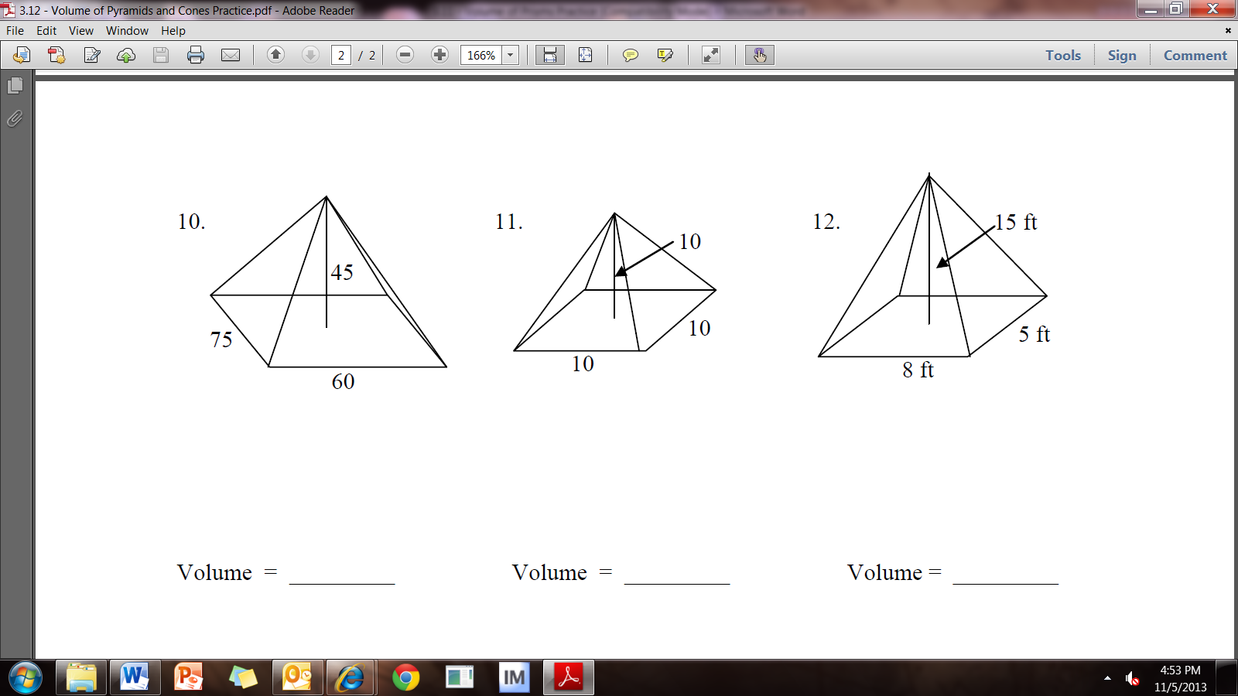







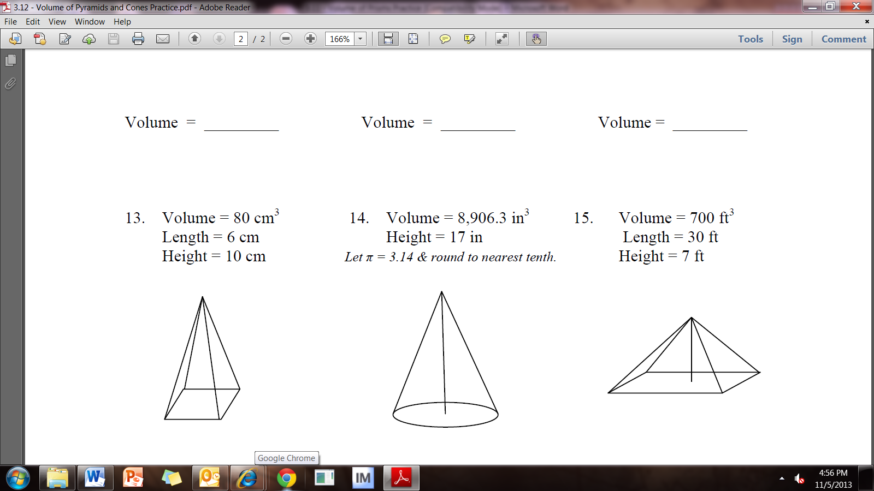

**Working Backwards: show ALL of your work**

1. Find the missing width of the base.
2. Find the radius.



1.  Find the missing width of the base.