~Notes Angles with Vertex Inside/Outside~
Vertex is INSIDE the Circle NOT at the Center
Formula:
- Solve for x:  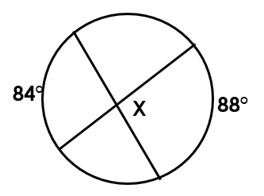 | - Solve for x:  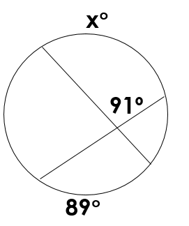

~Vertex is OUTSIDE the circle~
Formula:

- Solve for x:  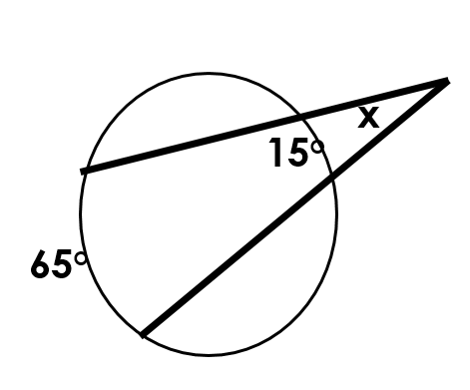 | - Solve for x:  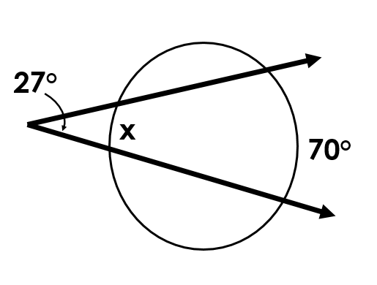
- Solve for x:

