Name: ___________________________________________ Date: ____________________________

**MULTIPLE CHOICE PRACTICE**

1. In right triangle ABC, angle A and angle B are complementary angles. The value of cos A is 5/13. What is the value of sin B?

a) 5/13 b) 12/13 c) 13/12 d)13/5

1. Triangle ABC is given below.



What is the value of cos A?

a) 3/5 b)3/4 c) 4/5 d) 5/3

1. In right triangle HJK, is a right triangle and tan Which statement about triangle HJK must be true?

a) sin b) sin c) sincos d)sin1 / cos



1. A 12 foot ladder is leaning against a building at a 75° angle with the ground.

Which can be used to find how high the ladder reaches up the side of the building?

a)  b) 

c)  d) 

1. A hot air balloon is 1200 feet above the ground. The angle of depression from the basket of the hot-air balloon to the base of a monument is 54°.



Which equation can be used to find the distance, d, in feet, from the basket of the hotair balloon to the base of the monument?

a)  b)  c)  d) 

1. Quadrilateral LMTP is an isosceles trapezoid.

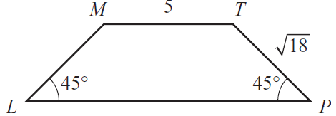

What is the length of ?

a) 10 b) 11 c) 5+2√18 d) 5+6√2

1. Bianca uses an angle-measuring device on a 3-foot tripod to find the height, h, of a weather balloon above ground level, as shown in this diagram.

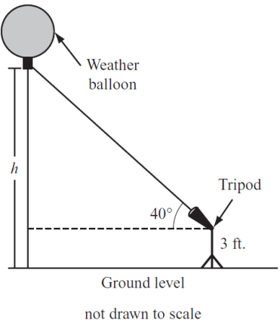

The balloon is at a 40° angle of elevation. A radio signal from the balloon tells Bianca that the distance between the tripod and the balloon is 25,000 feet.

Which expression represents the height, h, of the balloon above ground level?

a)  b) 

c)  d) 

1. Use this diagram of a cone to answer the question.

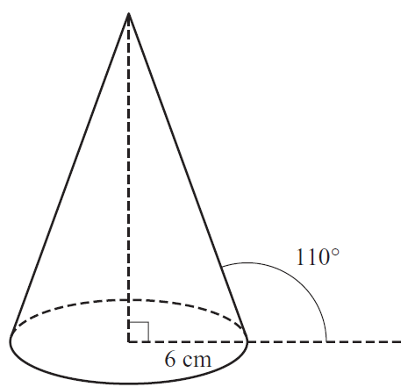

The base of the cone has a radius of 6 cm. Which expression represents the slant height, in centimeters, of the cone?

a)  b)  c)  d) 