~Perpendicular Lines Notes~
- Graphs:

- Equations:

Find the Opposite Reciprocal Slopes
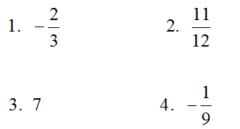
How to Write an Equation of a Line PERPENDICULAR to another and given a point
- Given ___________ should be solved for ___ (y = mx + b).
- Write down the _____________ ______________ slope of that line.
- ______________ m and (x, y) in y = mx +b.
- ________ for b.
- Write the _________ using m and b.
Write a line perpendicular to the line y = ½ x – 2 and passes through the point (1, 0). | Write a line perpendicular to the line y = -3x + 2 and passes through the point (6, 5).
Write a line perpendicular to the line 2x + 3y = 9 and passes through the point (6, -1). | Write a line perpendicular to the line y = 2x – 1 and passes through the point (2, 4).
Write a line perpendicular to the line and passes through the point (5, 1).

