~Area of a Sector Notes~
UNIT QUESTION: What special properties are found with the parts of a circle?
MMC9-12.G.C.1-5,G.GMD.1-3
Today’s Question: How do we find the area of a sector?
MMC9-12.G.C.5
2 types of Answers
Rounded | Exact
- Type the Pi button on your calculator  - Toggle your answer  - Round | - Type the Pi button on your calculator  - Pi will be in your answer  - TI 36X Pro gives exact answers

- Area:

- Formula:

Find the EXACT area
- r = 29 feet | - d = 44 miles

Find the area. Round to the nearest tenth.
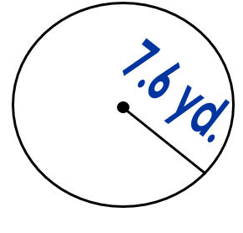 | 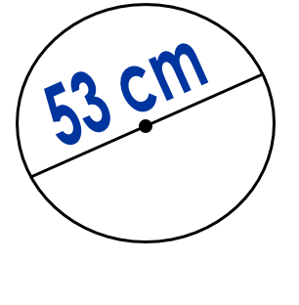
- Sector:

- Formula:

- Find the area of the sector to the nearest hundredths. | 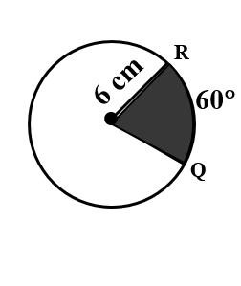
- Find the exact area of the sector. | 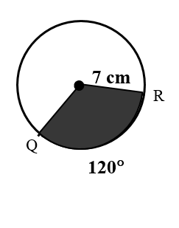
- Find the radius of the circle if the area of the circle is 225π cm².

- Find the radius. Round to the nearest hundredth. | 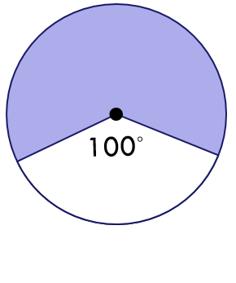
- Find the radius. Round to the nearest hundredth. | 