~Tangent & Secant Segments Notes~

**Two secants intersect OUTSIDE the circle**

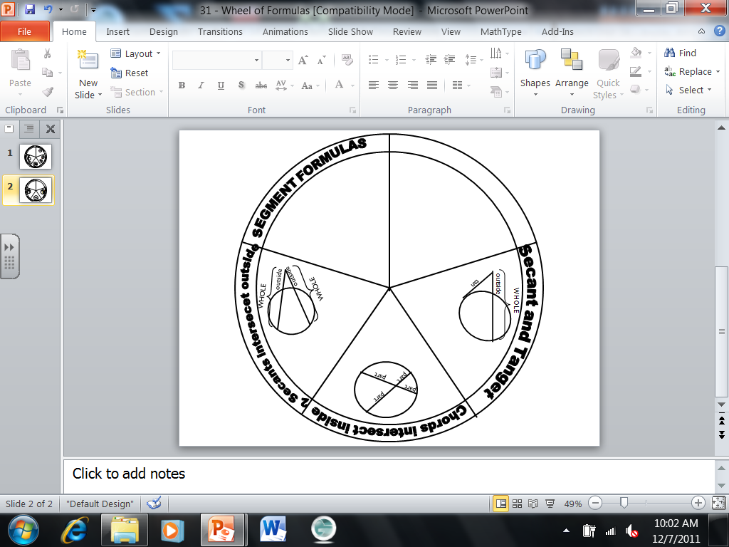

* **Formula:**

|  |  |
| --- | --- |
| 1. **Solve for x:** | 1. **Solve for x:** |
| 1. **Solve for x:** |  |

**Secant and Tangent intersect OUTSIDE the circle**



* **Formula:**

|  |  |
| --- | --- |
| 1. **Solve for x:** |  |
| 1. **Solve for x:** |  |
| 1. **Find KM** |  |