Name: ________________________________________________ Date: _______________________

Angles in Triangles Homework

Base Angles Theorem:
Find the value of x.
- 2)
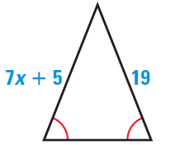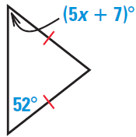

Sum of Interior Angles:
Solve for x.
3) 4)
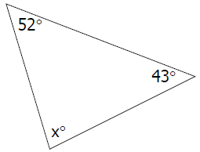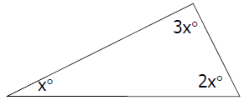

5) 6)
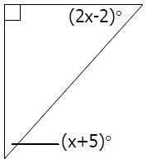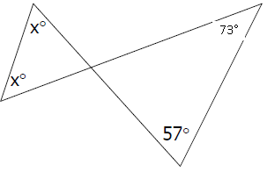

Exterior Angles Theorem:
- Find the missing angle 8) Solve for x.
