Name: ____________________________________________________________ Date: ________________________

**Unit 2 Part 1 Test Review**

**Missing Angles: Find x**

1) 2)

 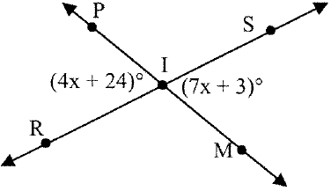

3) 4)

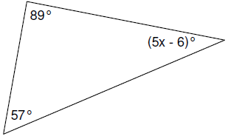 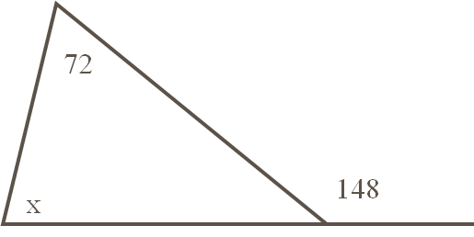

1. and are complementary. Solve for x and the measure of both angles.



6) The measure of one angle is 38 less than the measure of its supplement.

Find the measure of each angle.

1. One of two supplementary angles is 123° less than twice its supplement. Find the measure of both angles.

**Parallel Lines:**

8) Name the angles listed and the special property of each pair.



a)  and ______________________________

b)  and ______________________________

c)  and ______________________________

d)  and ______________________________

9) Given  and , find the measures of all the numbered angles in the figure.



10) Solve for x.

a) b)

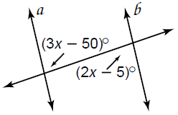 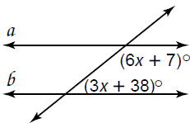

11) Solve for x and the missing angles.

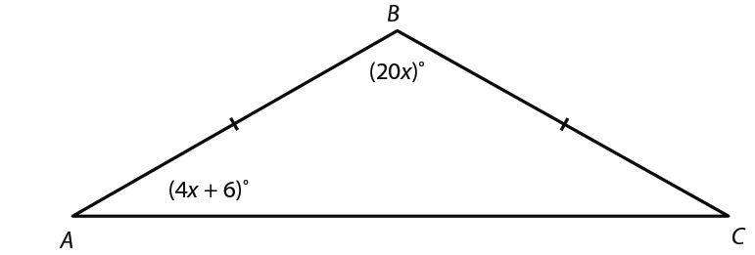

12) Solve for x and the missing angles.

